**Directions: You have 60 minutes to complete the following 30 multiple-choice questions. Choices A through D are answer choices for every problem. Choice E) NOTA stands for “none of these answers”. Scoring is as follows: 5 points for a correct answer, 1 point if left unanswered, and 0 points for an incorrect response. Figures are not necessarily drawn to scale. Good luck!**

1) Two angles of a triangle are 24° and 65°. What is the measure of the third angle?

**A) 271° B) 181° C) 91° D) 1° E) NOTA**

2) Find the positive geometric mean of 8 and 2.

**A) 8 B) 5 C) 4 D) 2 E) NOTA**

3) Wayne is watching a performance in a tent that is in the shape of a right circular cone. If the cone is 3 meters tall and has a radius of 5 meters, then what is the volume of the tent, in cubic meters?

**A)  B)  C)  D)  E) NOTA**

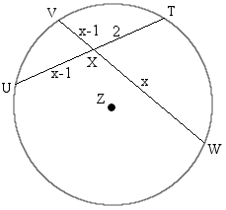4) In circle Z, chords TU and VW intersect at X. If VX measures *x*-1, WX has length *x*, UX has length *x*-1, and TX is 2 units long, find all possible values of *x*.

**A)**

**B) 2**

**C) 1**

**D) 2 and 1**

**E) NOTA**

5) Andrew, Brian, and Jessie are on points W, I, and N of triangle WIN. Each of them visualizes a median being drawn from their own point to the opposite side of the triangle. All of them walk along their respective medians and meet at the same point. What is that point called?

**A) Centroid B) Circumcenter C) Incenter D) Orthocenter E) NOTA**

6) Doreen is swinging on a high bar when – oh no, she falls! If she travels 10 feet at a angle of depression before hitting the ground, then how high up is the high bar, in feet? Assume the high bar is parallel to the ground and Doreen is of negligible size.

**A) 10 B)  C) 5 D) It’s on the ground E) NOTA**

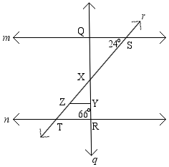7) Lines *m* and *n* are parallel. Transversal *q* intersects lines *m* and *n* at points Q and R, respectively, while transversal *r* intersects lines *m* and *n* at points S and T, respectively. Triangle XYZ is drawn such that XY is on line *q* and segment YZ is parallel to line *n*. What is the measure of ∠QXZ if ∠QSX is 24° and ∠QRT is 66°?

**A) 114° B) 90° C) 66° D) Impossible scenario E) NOTA**

8) The carnival ball pit is in the shape of a regular dodecagon. What is the measure of one of its exterior angles?

**A) 360° B) 180° C) 30° D) 12° E) NOTA**

9) Daniel is riding a motorcycle inside of a glass sphere of radius 3. Find the volume of the sphere.

**A) 36π B) 27π C) 18π D) 9π E) NOTA**

10) Circles X, Y, and Z are congruent circles with radius 2 and are all externally tangent to each other. What is the area of the region inside of triangle XYZ but outside of circles X, Y, and Z?

**A)  B)  C)  D)  E) NOTA**

11) Which of the following is/are logically equivalent to the statement: “If Samuel practices, then he can do a back flip”?

I. If Samuel does not practice, then he cannot do a back flip.

II. If Samuel cannot do a back flip, then he doesn’t practice.

III. If Samuel can do a back flip, then he doesn’t practice.

IV. Samuel can do a back flip if he practices.

**A) I only B) I and III C) II and IV D) IV only E) NOTA**

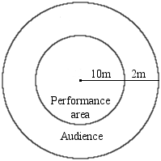12) The carnival’s performance area is in the shape of a circle of radius 10 meters. Another circle of radius 12 meters is made so that it is concentric (it shares the same center) with the performance area. The audience must stay outside of the performance area, but inside of the larger circle. What is the area of the space in which the audience must stay?

**A) 44π B) 22π C) 4π D) 2π E) NOTA**

13) Ben is inside of a cage in the shape of a rectangular prism with length 10 ft, width 10 ft, and height 5 ft. If he jumps in a straight line from one corner of the cage to the most distant corner, how far does he jump? Assume Ben has no volume.

**A) 15 ft B)  ft C) 10 ft D)  ft E) NOTA**

14) Nick is walking on tightrope AB of length 18. Let points C and D trisect line AB. If Nick started at A and has walked two thirds of the length of segment CD, then how much farther does he have to walk until he reaches point B? (Note : Point C is closer to point A and point D is closer to point B.)

**A) 12 B) 10 C) 9 D) 8 E) NOTA**

15) Nick is once again crossing a tightrope, but this time he is riding a unicycle! If the tightrope is 150 meters long and the unicycle’s wheel has radius 5 meters, how many complete revolutions will the wheel make?

**A) 30 B) 10 C) 5 D)  E) NOTA**

16) Isosceles trapezoid ABCD is shown below where XY is the median. If base AB is 6 units long and base CD is 10 units long, then how long is the median?

A

B

6

Y

X

C

10

D

**A) 16 B) 8 C) 7 D) 2 E) NOTA**

17) Allison is jumping around on a trampoline for no apparent reason. If Allison jumps into the air at (-3,2) and lands at (0,-2), then how much linear ground distance did she cover?

**A) 25 B) 16 C) 9 D) 5 E) NOTA**

18) An analog clock shows that the time is currently 1:00. Find the degree measure of the smaller angle formed by the minute and hour hands of the clock.

**A) 330° B) 300° C) 60° D) 30° E) NOTA**

19) A square is inscribed in a larger square of side length 2. What is the area of the smallest such square?

**A) 4 B) 2 C) 1 D)  E) NOTA**

20) Jamie just bought a bag of popcorn that is in the shape of a closed rectangular prism. After eating all of the popcorn, Jamie notices that the bag is 6 cm wide, 10 cm long, and the outside of it has a surface area of 280 cm. How tall is the bag of popcorn?

6 cm

10 cm

**A) 10 cm B) 8 cm C) 5 cm D) Cannot be determined E) NOTA**

21) Parallelogram ABCD has. What is the measure of?

**A) 128° B) 62° C) 52° D) 38° E) NOTA**

22) Which of the following **cannot** be the sides of a triangle?

**A) 3,3,4 B) 2,3,4 C) 1,2,3 D) 4,4,4 E) NOTA**

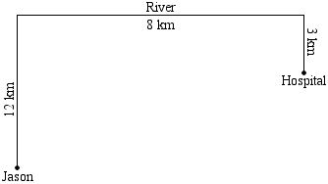23) Jason is performing his “ring of fire” routine when his shirt catches on fire! He is currently 12 kilometers away from a river (which happens to be a straight line) that he must touch before going to the nearest hospital which is 8 kilometers down the river from where he is and 3 kilometers away from the river. What is the shortest distance Jason can travel to the hospital if he must first stop by the river?

**A) 17 km B)  km C)  km D) 8 km E) NOTA**

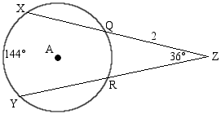24) Circle A, shown below, has secants XZ and YZ intersecting the circle at points Q and R, respectively. ∠XZY is 36° and arc XY measures 144°. What is the measure of ∠QAR if segment QZ has length 2?

**A) 144° B) 72° C) 60° D) 36° E) NOTA**

25) Two legs of a right triangle are 7 and 24. What is the length of the hypotenuse?

**A) 29 B) 27 C) 25 D) 23 E) NOTA**

26) Shiming notices that the tent that he’s in is in the shape of a regular octagon. If this is true, how many diagonals does it have?

**A) 40 B) 28 C) 20 D) 4 E) NOTA**

27) A white cube of side length 6 is composed of smaller unit cubes. The large cube is dipped in purple paint so that all of the unit cubes that make up the large cube’s surface have at least one face painted. How many unit cubes remain entirely unpainted?

**A) 216 B) 152 C) 125 D) 64 E) NOTA**

28) A right triangle has an angle measuring 45°. If the hypotenuse has length 5, what is the length of the median drawn to the hypotenuse?

**A) 10 B) 5 C)  D) Cannot be determined E) NOTA**

29) How many sides does an icosagon have?

**A) 100 B) 50 C) 20 D) 12 E) NOTA**

30) What is the sum of the measures of the interior angles of a hexagon?

**A) 1620° B) 1260° C) 1080° D) 720° E) NOTA**